Home building compensation scheme report
30 June 2018
  - State Insurance Regulatory Authority
Contents
Highlights 3
Introduction 5
Preamble 5
HBC scheme data 6
Caution in interpreting the information 6
Part 1: Information pertaining to policies issued since 1 July 2010 7
1. Eligibility information 7
Builder eligibility 7
2. Securities held by icare HBCF from builders 10
3. Home Building Compensation (HBC) certificate of insurance information 12
New certificate of insurance issued to builders 12
Comparing ABS building approvals for NSW with new certificates of insurance issued 15
4. Premiums information 17
5. Claims information 20
Number of notifications of loss and claims lodged 21
Claim development 25
6. Claim payments information 28
Claim payment development 31
7. Premiums and claim costs 33
Part 2: Claims information for policies issued prior to 1 July 2010 35
Number of runoff insurer notifications of loss and claims lodged reported 35
Runoff insurer claim payments 40
Appendices 42
Appendix 1 - Home building compensation scheme changes in NSW 42
Appendix 2 - Glossary 45
Appendix 3 - Data quality statement 47

Highlights
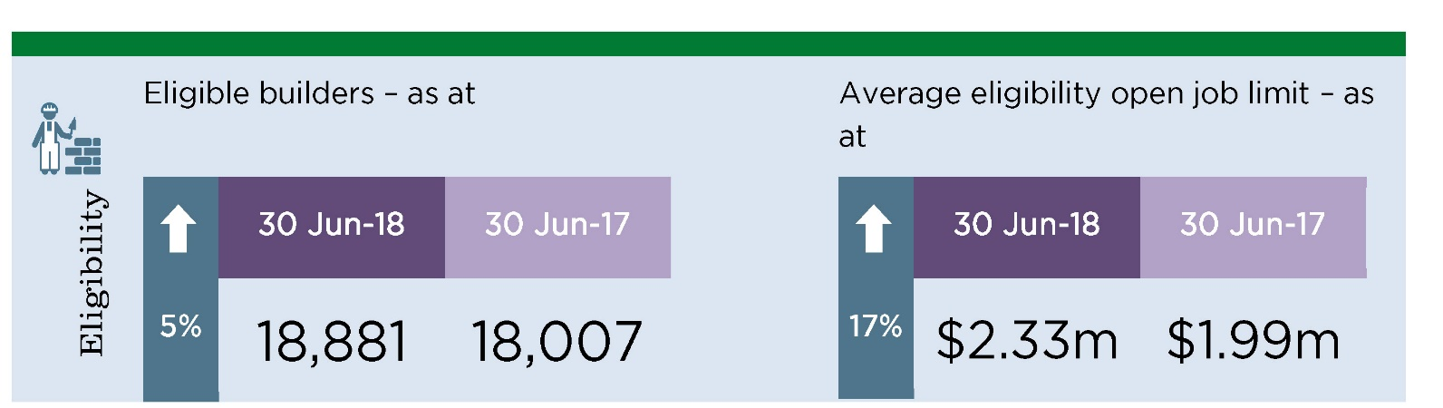
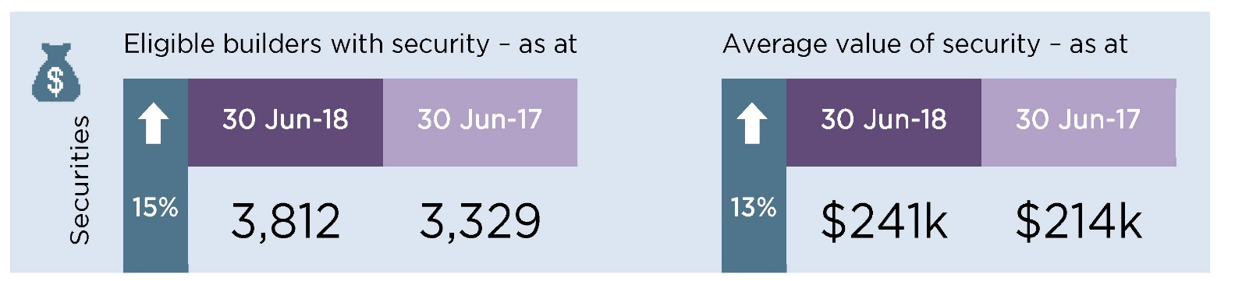
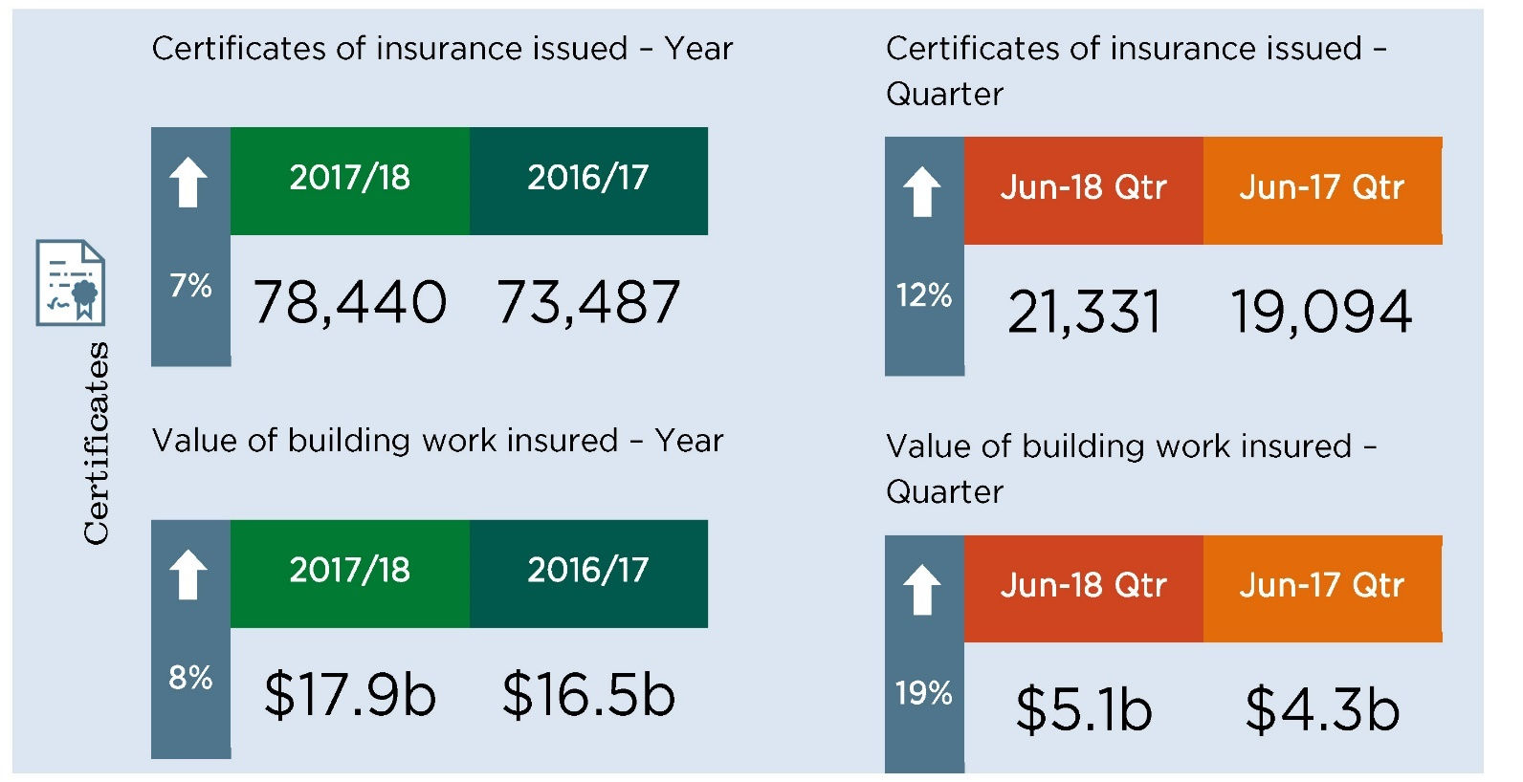
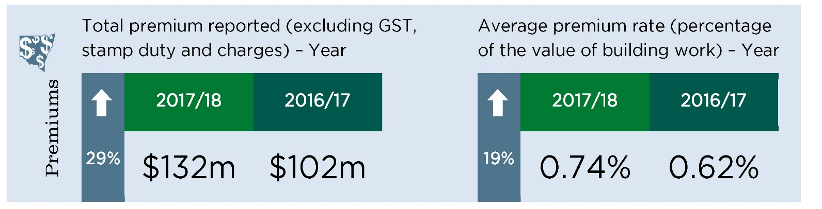

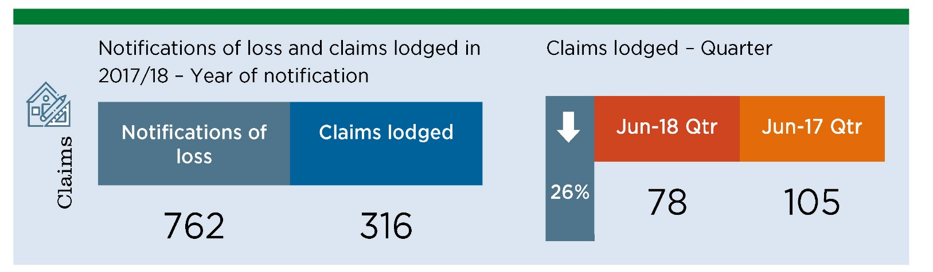
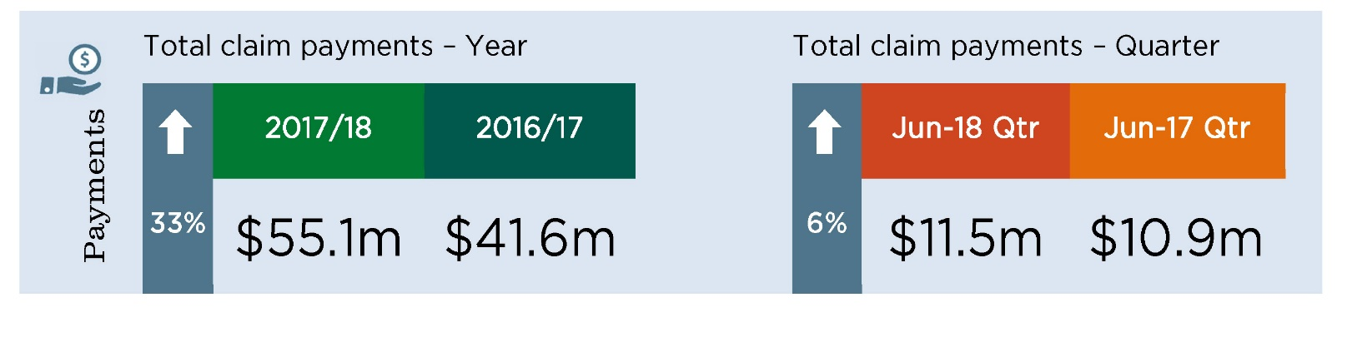
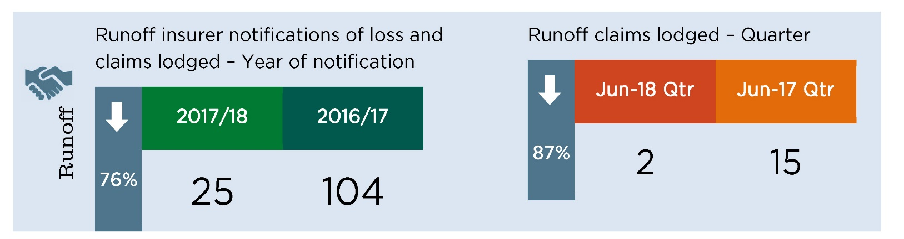
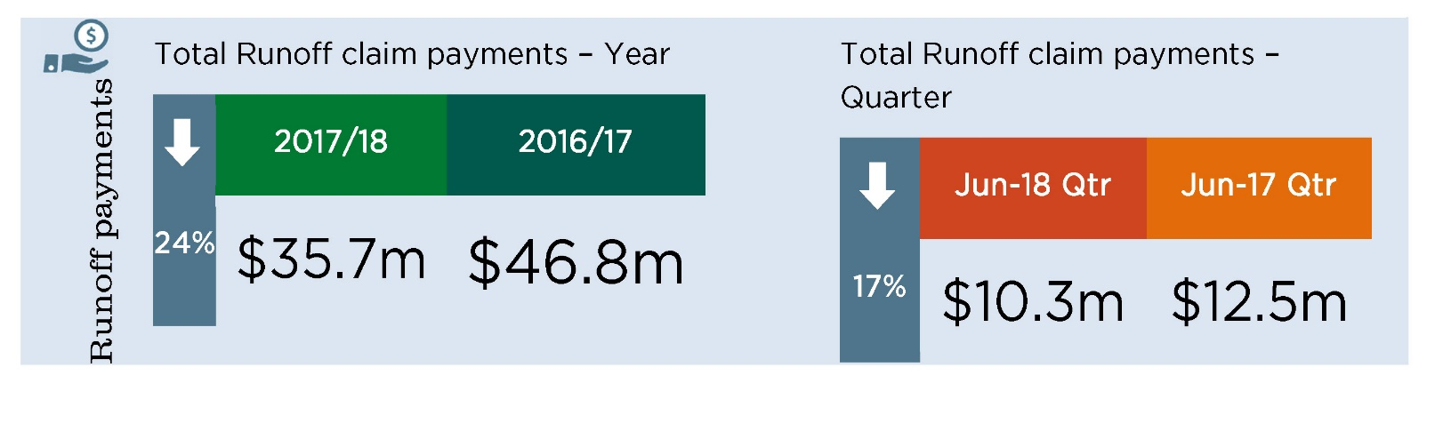

Introduction

Preamble
The Home Building Compensation (HBC) Scheme is governed by the Home Building Act 1989. The Scheme provides a last-resort safety net for homeowners in NSW faced with incomplete and defective building work carried out by licensed builders and trades or specialists contractors. Residential building work over $20,000 including GST is insured under the Scheme, unless exempt. Work that is exempt from the Scheme includes work involved in the construction of new multi-storey buildings (buildings with more than three storeys and containing two or more separate home units).
HBC insurance must be at least $340,000, or $300,000 if the insurance was issued before 1 February 2012. The insurance extends to subsequent purchasers of the property (as long as the insurance has not been exhausted by a prior claim). The Scheme was formerly known as the Home Warranty Insurance Scheme, and covered situations where builders or contractors failed to complete residential building work or to rectify defects.
From 1 September 2015, the State Insurance Regulatory Authority (SIRA) assumed the regulatory functions of the HBC Scheme, which were previously undertaken by NSW Fair Trading.
The NSW Self Insurance Corporation (trading as icare HBCF) has written all HBC insurance in NSW since 1 July 2010.
HBC insurance written in NSW prior to 1 July 2010 was written by insurers approved by the Minister. These insurers are referred to as ‘runoff insurers’ and all ceased writing business on or before 30 June 2010. Runoff insurers continue to manage and settle claims on policies written up until the date they ceased writing HBC business.
In June 2017, the NSW Parliament passed the Home Building Amendment (Compensation Reform) Act 2017. The Amendment Act commenced on 1 January 2018 and allows private insurers or alternate indeminity product providers to apply to SIRA for a license to enter home building compensation market. At the time of the writing of this report, icare HBCF is the single HBC licence holder.

HBC scheme data
SIRA collects data on HBC contracts of insurance and claims in accordance with HBC guidelines to monitor the operation of the scheme.
The information in this report applies only to the scheme’s operations since 1 July 2002. Since 1 July 2002 the HBC scheme has offered protection in the event of the death, disappearance or insolvency of a builder or tradesperson only. For contracts of insurance entered into from 19 May 2009, claims may also be made in situations where a builder or tradesperson’s licence is suspended for failure to comply with a mandatory monetary order of the NSW Civil and Administrative Tribunal (NCAT) or a court in favour of the homeowner.
The information in this report consists of two parts:
Part 1: Information pertaining to policies issued since 1 July 2010
icare HBCF has been the sole provider over this period.
Part 2: Claims information for policies issued prior to 1 July 2010
The information in Part 2 of the report relates to claims information for contracts of insurance entered into by runoff insurers prior to 1 July 2010.
Further information on the HBC scheme and reforms is available at https://www.sira.nsw.gov.au.https://www.sira.nsw.gov.au
For detailed data tables refer to the Excel workbook on the supplement HBC Scheme Data Tables June 2018.

Caution in interpreting the information
Home building compensation is a ‘long tail’ class of business:
- There may be a significant delay between the date a builder enters into a contract of insurance for a building project, and the commencement date of work on the project
- The duration of a building project may range from a few weeks to several years
- For incomplete work, the period of insurance is twelve months from the date of the failure to commence the work or cessation of work (if it was started).
- If claim involves defective work, the period of insurance is either six years (major defects) or two years (all other defects).
- It may take some time for homeowners to identify a loss, lodge a claim with an insurer and for the insurer to assess the claim and arrange rectification.
HBC claims experience varies greatly from year to year and is impacted by conditions in both the home building market and broader economy. Periods of high construction activity are generally associated with fewer insolvencies, and therefore fewer claims to the Scheme. The reverse is true of periods with low construction activity.
Claims lodged or paid in any given year can relate to insurance policies issued many years ago.
It is important to consider the characteristics of HBC insurance and the impact of broader economic conditions when interpreting the information in this report.

Part 1: Information on policies issued since 1 July 2010

Eligibility information
Key comments:
- There has been a 5% increase in the number of eligible builders over 2017/18 – increasing from 18,007 as at 30 June 2017 to 18,881 as at 30 June 2018.
- As at 30 June 2018, the average eligibility open job limit was $2.3 million, an increase of 17% from 30 June 2017.
- There was a 23% increase in the total eligibility open job limit to $44.1 billion as at 30 June 2018 compared to $35.9 billion as at 30 June 2017.
- There was a noticeable higher proportion of eligible builders who were granted open job limits in the over $1 million to $2 million, and over $2 million to $3 million brackets, as at June 2018 compared with the previous year.
- The proportion of builders with open job limits over $1 million has increased from 37% as at 30 June 2017 to 58% as at 30 June 2018. This change in the composition of builder eligibility limits occurred mainly in the Mar 2018 quarter.
- As at 30 June 2018, 30% of eligible builders have no projects currently under construction, while 5% are utilising more than 90% of their open job limit.
‘Eligibility’ is the term used to describe the approval by icare HBCF to enable a builder to apply for a contract of insurance for residential building work in NSW, and the conditions under which the insurance may be granted. A builder’s eligibility limits the maximum number, value, and types of building projects for which icare HBCF will insure the builder.
The eligibility data in this section is reported at the end of each financial year.

Builder eligibility
From August 2015, icare HBCF changed its approach to eligibility. Prior to August 2015 icare HBCF issued eligibility, and measured builder activity within eligibility limits, on an annual basis. These were known as ‘annual turnover limits’. From August 2015 onwards, icare HBCF has instead issued and monitored eligibility on the basis of the projects a builder is doing at any point in time. These are known as ‘open job limits’.
Figure 1 shows the number of builders with eligibility at the end of each financial year, broken down by the maximum dollar value of work for which they were eligible (values grouped into bands by ‘annual turnover limits’ for the period to June 2015 and ‘open job limits’ thereafter.)
Figure 2 shows the total and average open job limits for builder eligibility at the end of each financial year. (By the annual turnover limits bands for June 2015 and earlier.)
Figure 3 shows the number of eligible builders broken down by their utilisation band (i.e. the extent to which builders have used up their available eligibility). The utilisation percentage is calculated as the used contract amount divided by approved job value.
Figure 1: Breakdown of builder eligibilities by number and value at the end of each financial year
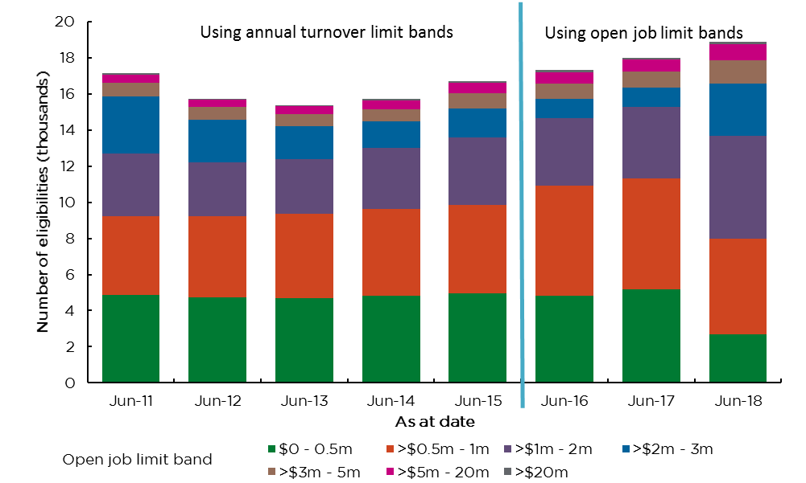
Note for Figure 1 and Figure 2: From August 2015, icare HBCF changed its eligibility limits for builders from ‘annual turnover limits’ to ‘open job limits’.
Figure 2: Total ($ billions) and average ($ millions) value of builder eligibilities
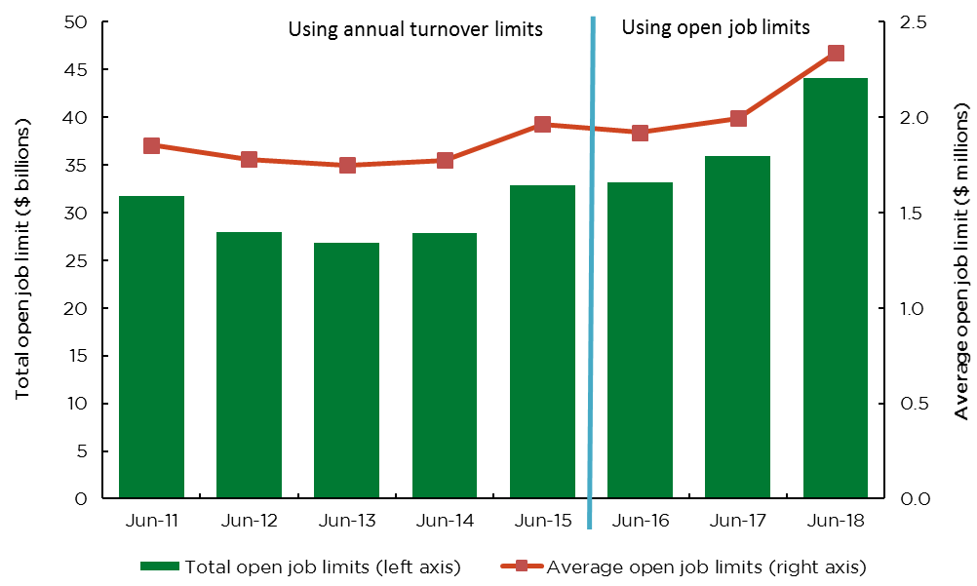
Figure 3 Builders eligiblility utilisation as at 30 June 2018
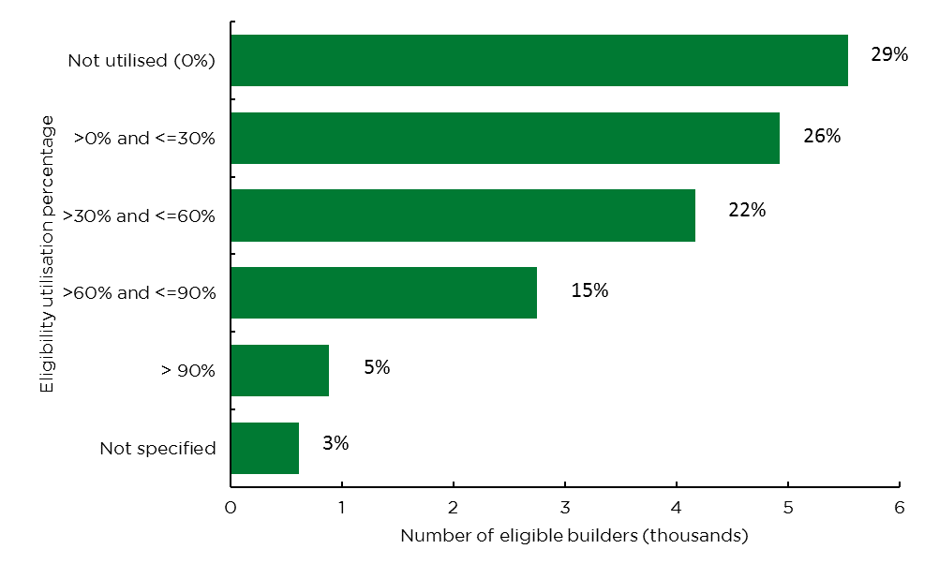Refer Appendix 2 Glossary for definition of eligibility utilisation.

Securities held by icare HBCF from builders
Key comments:
- There has been a 15% increase in the number of eligible builders with security over 2017/18 – increasing from 3,329 as at 30 June 2017 to 3,812 as at 30 June 2018.
- The average value of security provided by eligible builders has increased by 13% over 2017/18 - increasing from $214K as at 30 June 2017 to $241K at 30 June 2018.
icare HBCF requires some builders to provide security in the form of a deed of indemnity as a condition of approving eligibility or providing a contract of insurance for a specific project. In some circumstances, builders may provide a bank guarantee.
Disclaimer: Note that the eligibility deeds of indemnity expire 36 months after the completion date of the last building project where a claim or loss notification is not received. The information in Figure 4 and Figure 5 does not reflect whether the deeds of indemnity have met the above expiry conditions.
Figure 4 Number of eligible builders with securities held by insurer as at each quarter
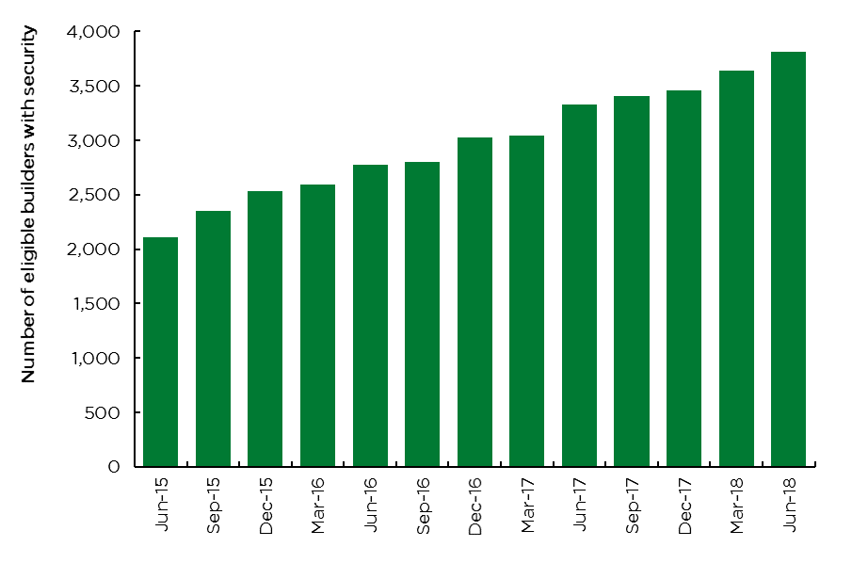
Figure 5 Average value of security ($ thousands) for eligible builders held by insurer as at each quarter
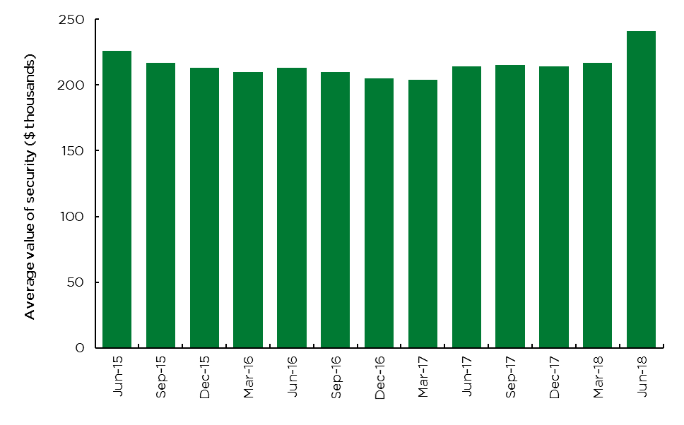

3. Home Building Compensation (HBC) certificate of insurance information
Key comments:
- The total number of certificates of insurance issued over 2017/18 was 78,440 – a 7% increase from 2016/17 levels. The renovations construction type has experienced the largest growth in the number of certificates of insurance issued over 2017/18.
- Over 2017/18, average contract value of certificates of insurance increased by 3% for new single dwelling, the largest construction type as measured by the number of certificates of insurance issued and total premium received.
- The total contract value for certificates of insurance issued over 2017/18 was $17.9 billion – this reflects an 8% increase from the $16.5 billion contract value for certificates of insurance issued over 2016/17.
- Total contract value for certificates of insurance issued in the June 2018 quarter has increased by 19% compared to the June 2017 quarter.
- The total value of contracts for building work recorded on certificates of insurance issued for new single and multiple dwellings of three storeys or less closely follows the value recorded in ABS building approvals data for NSW.

New certificate of insurance issued to builders
Figure 6 shows the number of new certificates of insurance issued by construction type and year. Cancelled certificates have been excluded from these figures.
Figure 7 displays the average building contract value covered by certificates of insurance by construction type and year.
Figure 8 displays the total building contract value covered by certificates of insurance by construction type and year.
Figure 6: Number of certificates of insurance by issue year and construction type
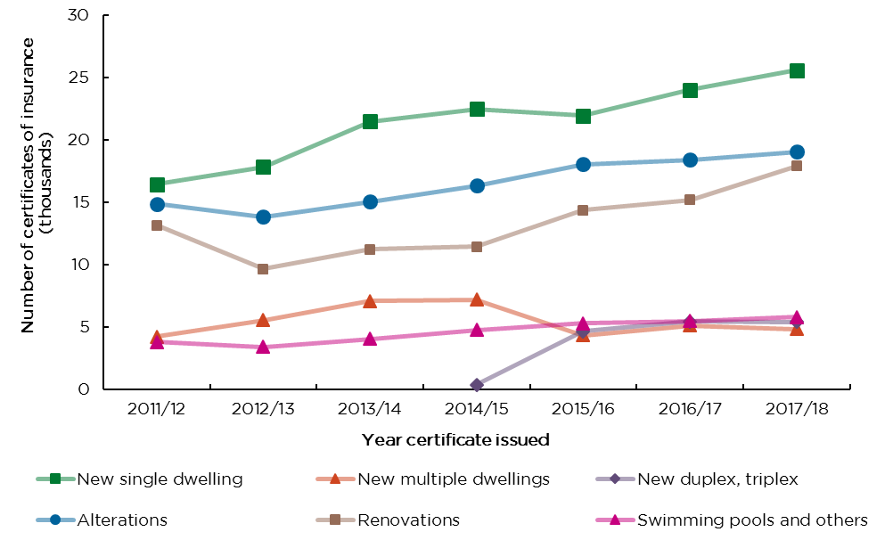

Figure 7: Average building contract value ($ thousands) per dwelling over time by construction type
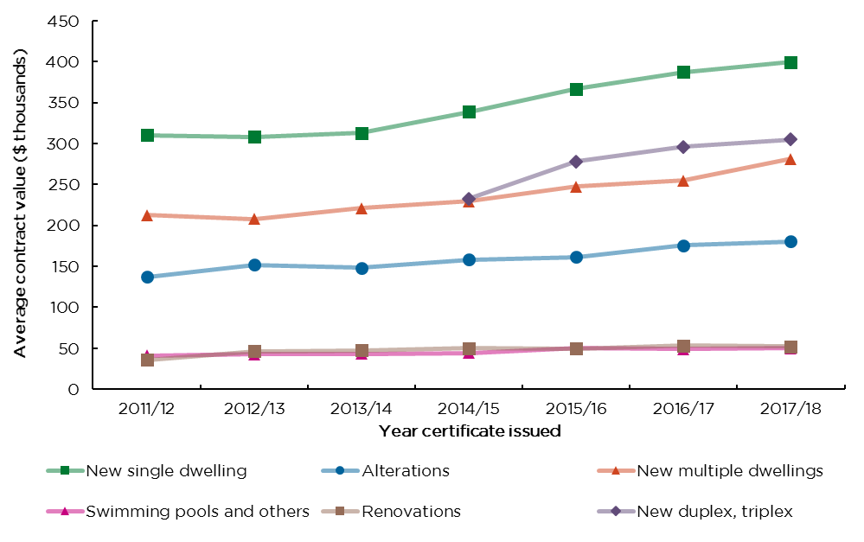
Figure 8: Total building contract value ($ billions) over time by construction type
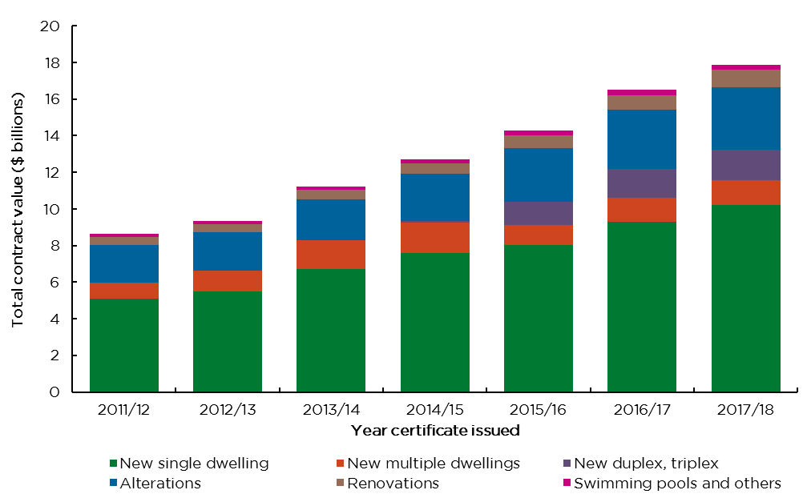

Comparing ABS building approvals for NSW with new certificates of insurance issued
Figure 9 displays the number of certificates of insurance issued for new single and new multiple dwellings of three storeys or less with Australian Bureau of Statistics (ABS) NSW building approvals data.
Figure 10 displays the total building contract value listed on the certificates of insurance issued between the two sources.
Public sector work has been excluded from the ABS data. SIRA notes that the ABS data will include some work that is exempt from the requirement to purchase HBC contract of insurance.
Figure 9: Number of ABS building approvals and certificates of insurance issued over time
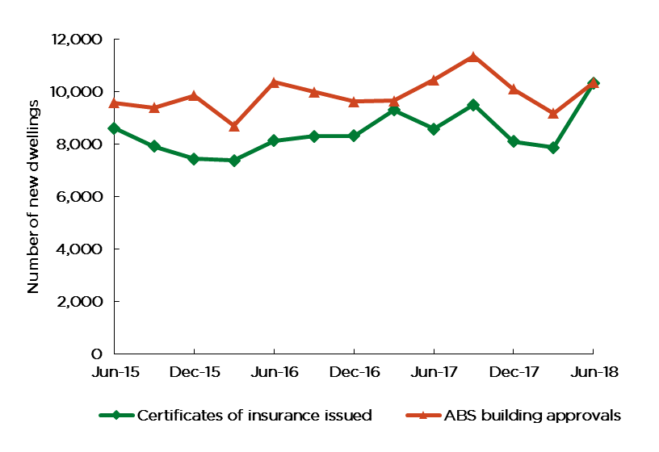
Figure 10: Value ($ millions) of ABS building approvals and certificate of insurance issued over time
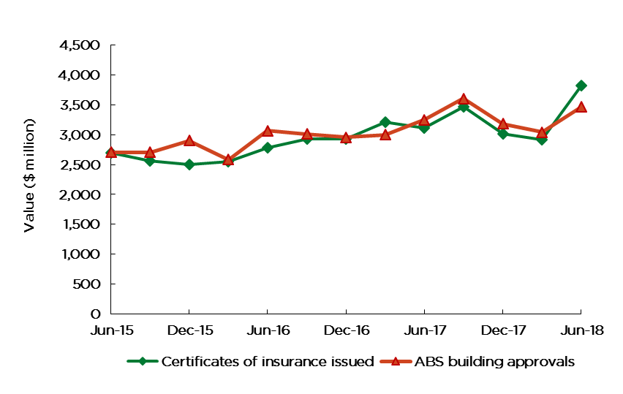

4. Premiums information
Key comments:
- The total premium reported over 2017/18 increased to $132 million due to growth in the number of certificates of insurance issued and increases in premium rates charged.
- The observed premium rates for ‘new multiple dwelling’ and ‘new duplex, triplex’ have increased significantly over two stages in the June and December 2017 quarters, due to premium rate changes by icare HBCF in April and October 2017. In contrast, the observed premium rate for ‘swimming pools and others’ and renovation fell in June 2017.
- Despite recent increases in premium rates for the ‘new multiple dwelling’ and ‘new duplex, triplex’ construction types (see Figure 13), observed premium rates for these construction types continue to be below the breakeven rates. This has result in total collected premiums being less than total projected liabilities for the scheme, as shown in Figure 34 on page 34. icare HBCF has forecast to the market its intention to continue to increase premium rates for these construction types in several tranches over the next 24 months, to bring premiums up to the breakeven rate. Premium rates for all other construction types have stabilised at or near respective breakeven rates.
- Over the June 2018 quarter, the observed premium rate was 0.6% for new single dwellings, the largest construction type as measured by the number of certificates of insurance issued and total premium received.
The premiums set out in this report exclude GST, stamp duty and any additional fees that may be charged on top of HBC premiums.
Figure 11: Total premium reported ($millions) and number of certificates of insurance issued by year
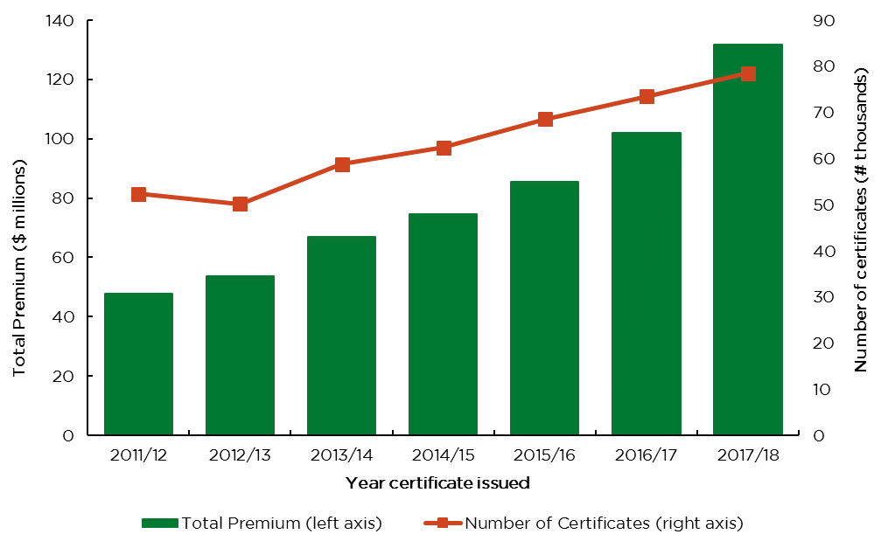

Figure 12: Total premium reported ($ millions) by construction type and year
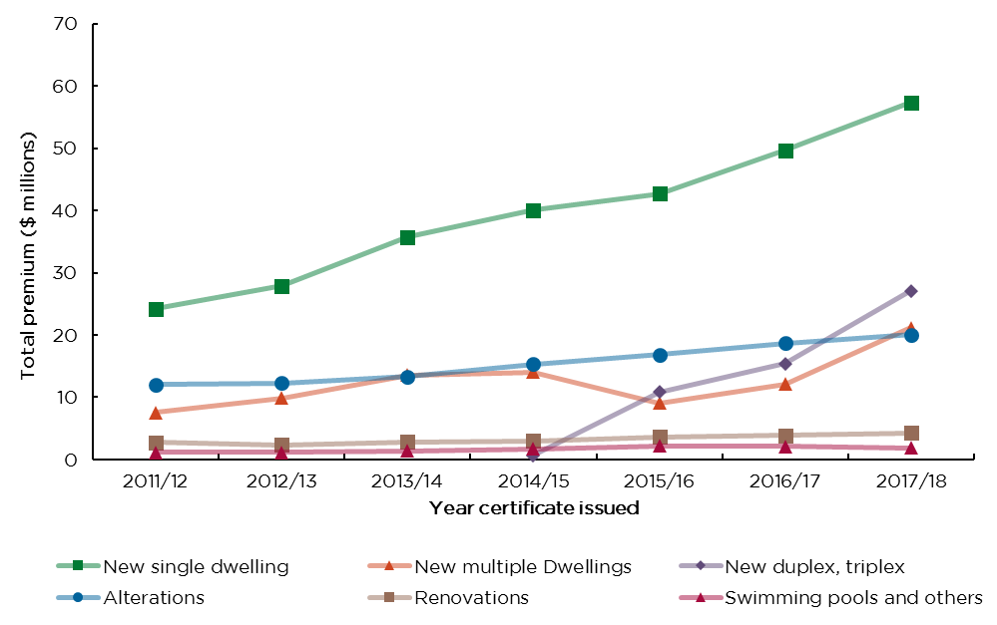
Figure 13: Observed premium rate (% of contract value) by construction type and year
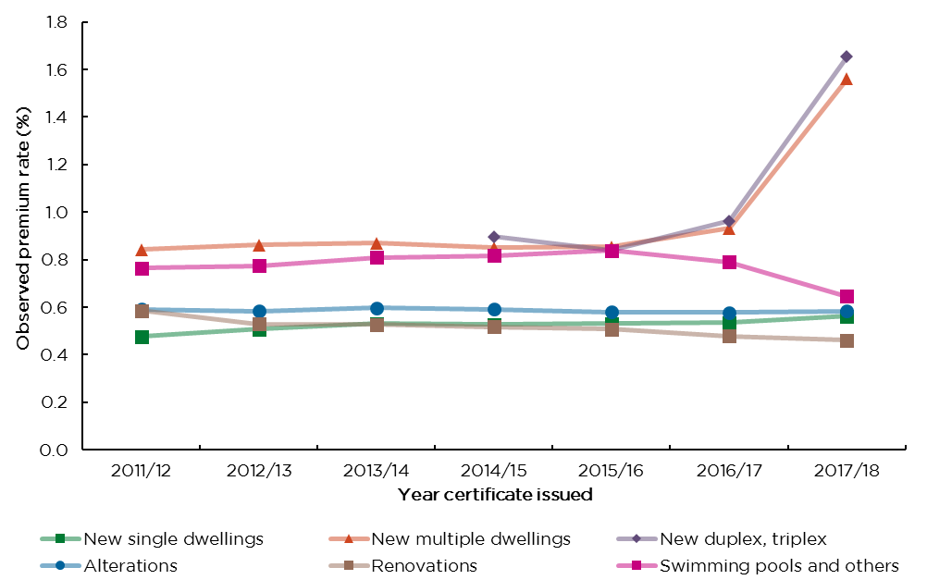
Note: The observed premium rates for ‘new multiple dwelling’ and ‘new duplex, triplex’ have increased in 2017/18 due to premium rate changes by icare HBCF as can be seen in Figure 13 and 14, while premium rate for ‘swimming pools and others’ and renovation reduced as can be seen in Figure 14.
Figure 14: Observed premium rate (% of contract value) by construction type and quarter
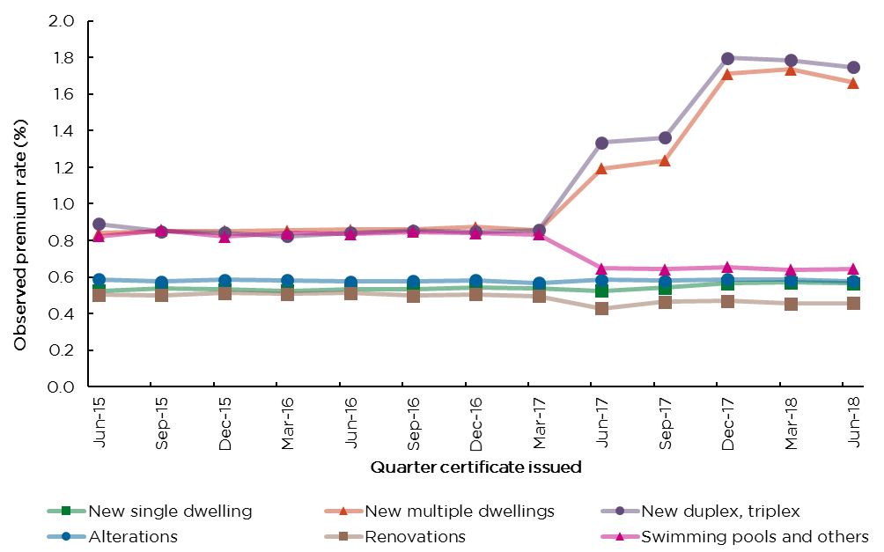

5. Claims information
Key comments:
- Over 2017/18, there were 762 notifications of loss. For comparison purposes, there were 768 notifications of loss over 2016/17.
- The number of claims lodged (i.e. notifications of loss which have progressed to become claims lodged), hereinafter referred to as ‘claims’, has decreased by 37%, dropping from 500 in 2016/17 to 316 in 2017/18.
- Of the claims lodged in 2017/18, 156 (50%) related to new single dwellings. Majority of claims are classified as major defects.
- Of those claims lodged where liability has been assessed, liability has been accepted for 76% of claims.
- For claims lodged where liability was denied, the primary reasons given were: ‘builder not insolvent’, ‘not deemed a defect’ and ‘out of time’.
- Of those claims lodged where the principal cause has been determined, insolvency accounted for 85% of claims.
- The number of claims lodged related to more recent certificate issued years are developing more favourably than for the 2010/11 and 2011/12 certificate issued years.
- The number of claims lodged relating to non-completion develop sooner than defect claims.

Care should be taken in interpreting claims data for recent years, as it can take many years for claims related to building defects to emerge, and for the full claim payments and costs to be known. Note:
- The number of claims is also related to the number of certificates issued, seen in Figure 11 on page 17 (i.e. the greater the volume of certificates of insurance issued (exposure), the higher the expected number of claims, all else being equal).
- It is important to consider claims “emergence / development patterns” when assessing experience.
- Defect claims have a longer “emergence / development pattern” than non-completion claims.
- The notifications of loss and claims lodged in this section relate to policies issued from 1 July 2010.

Home owners can notify their insurer that they have suffered a loss in order to preserve their ability to claim beyond the period of insurance in some circumstances. Note that not all notifications of loss necessarily progress to become a claim lodged. Notifications of loss can be finalised with no claim lodgement, for example if a home owner succeeds in obtaining remedy from their builder while they are still solvent.
Apart from Figure 15 which relates to notifications of loss (including notifications of loss which have progressed to become a claim lodged), all figures in this section of the scheme report relate only to claims lodged based on year of notification of loss.
Note that the count of the number of claims lodged is determined by their recorded liability status as at the current reporting date of 30 June 2018. At a subsequent reporting date, say as at 30 June 2019, the recorded liability status of some notifications of loss may change as they progressed to become claims lodged, due to changes in the liability decision by the insurer. This would result in a different count of number of claims lodged compared to the historical data for past quarters as reported in the 30 June 2018 report, particularly for more recent quarters.

Number of notifications of loss and claims lodged
Figure 15: Number of notifications of loss reported by year
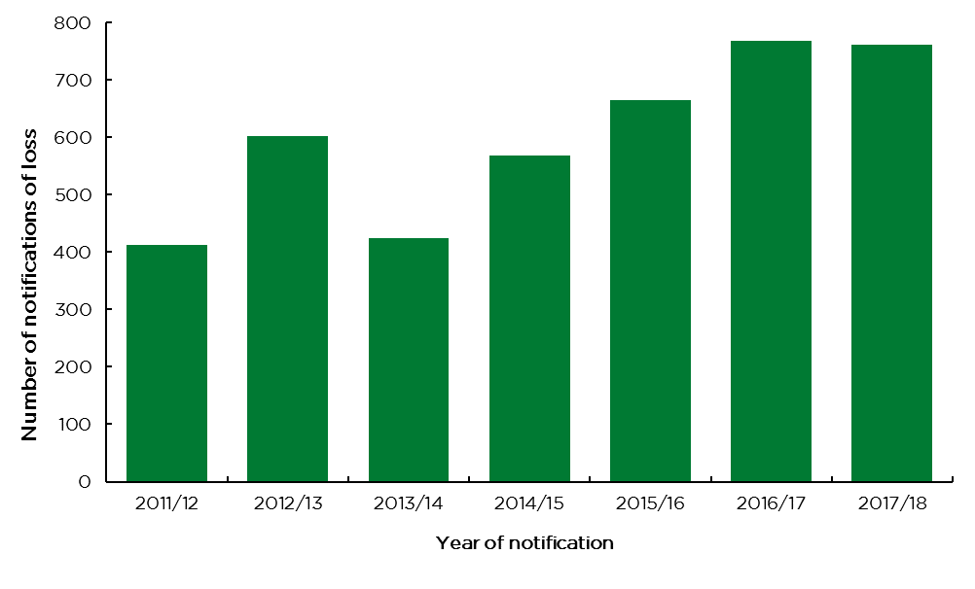
Figure 16: Number of claims lodged by year
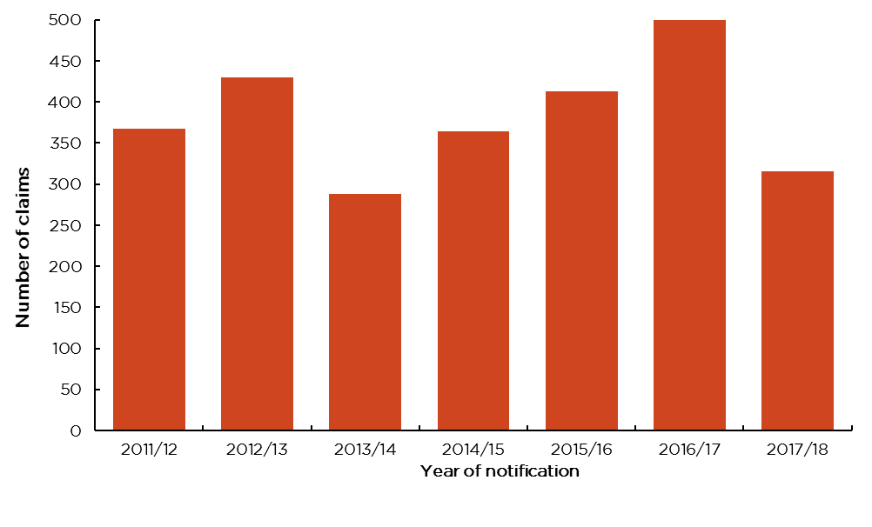
Figure 17: Number of claims lodged by year and claim status as at 30 June 2018
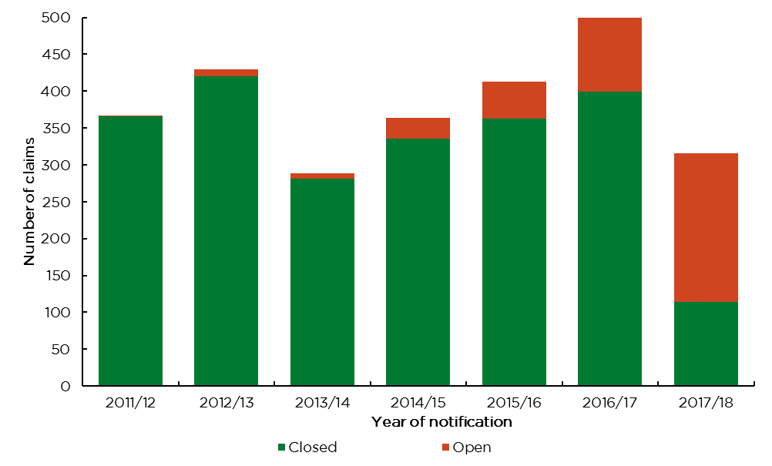
Figure 18: Number of claims lodged by year and liability status
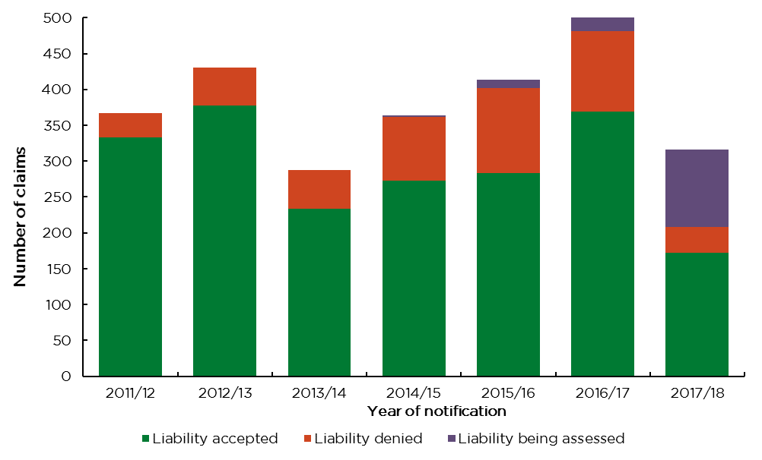
Figure 19: Number of claims lodged where liablity has been denied by year and reason denied
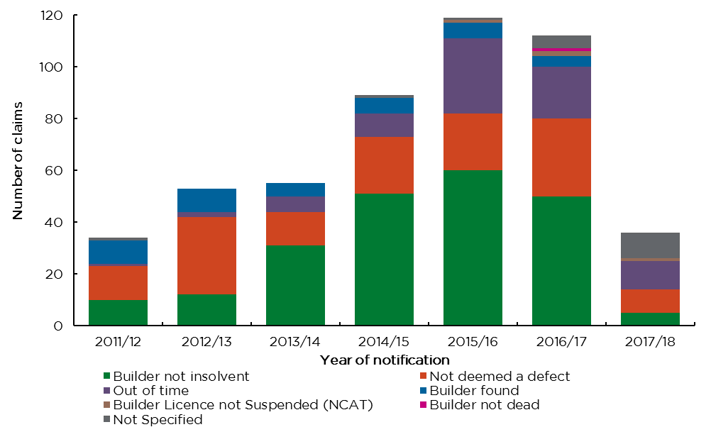
Figure 20: Number of claims lodged by year and principal cause
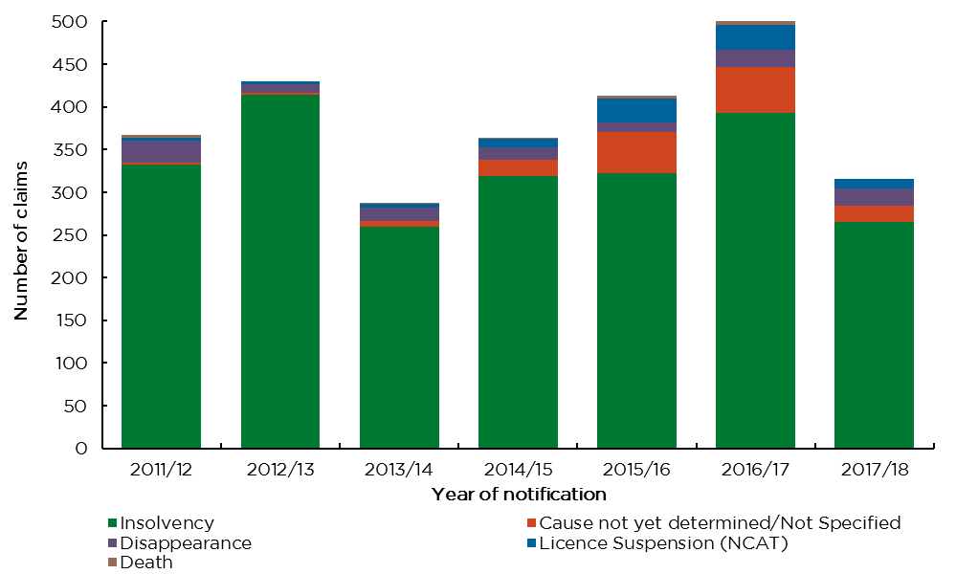
Claims where the cause is not specified are instances where claims do not have a claim type recorded by the insurer (i.e. claims still being assessed) and denied claims.
‘Other loss’ claims in the following figure refers to defect claims that are not classified as a major defect. ‘Multiple claim type’ claims refer to claims lodged as reported by the insurer with more than one claim type.
Figure 21: Number of claims lodged by year and type of claim
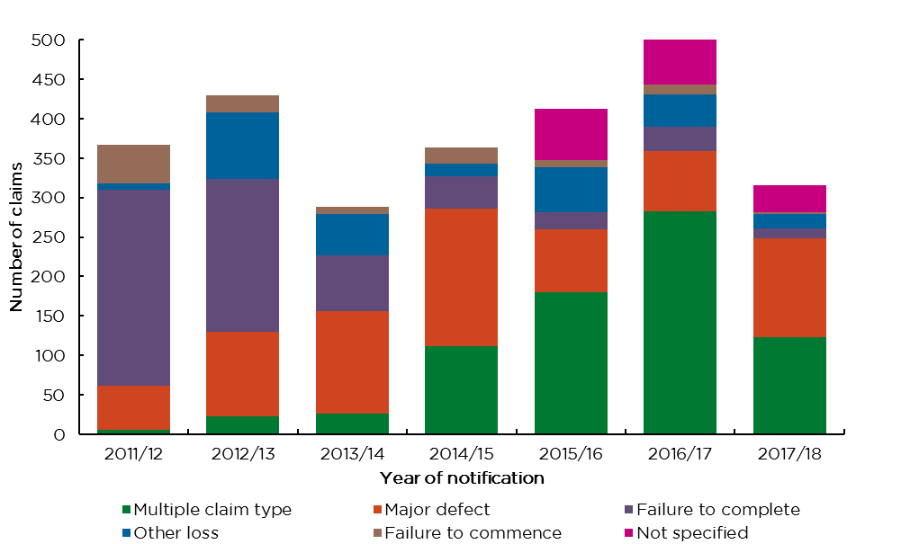

Figure 22: Number of claims lodged by year and construction type
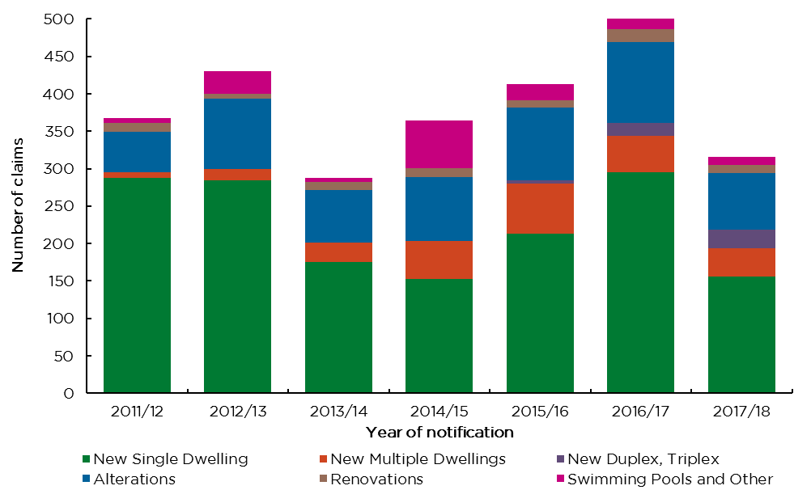

Claim development
Claim development charts facilitate:
- A comparison of cumulative number of claims by year insurance issued at the same stage of development. That is, they allow experience to be compared on a like-for-like basis.
- A greater understanding of the typical claim development patterns.
In these charts, the development year refers to the difference between the financial year of claim lodgement and the financial year of certificate of insurance issued. Non-completion claims refer to failure to commence and failure to complete claims, while ‘other claims’ refer to major defect claims, other loss claims and claims with multiple claims types or no claim types.
Figure 23: Total claims - cumulative number of claims lodged by year insurance issued
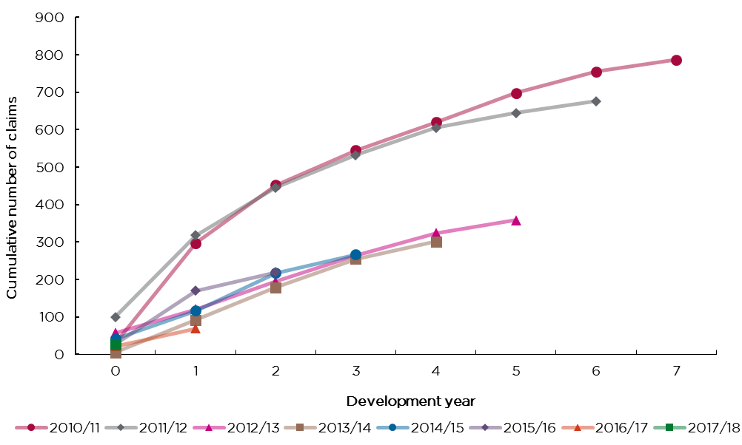
Figure 24: Non-completion claims - cumulative number of claims lodged by year insurance issued
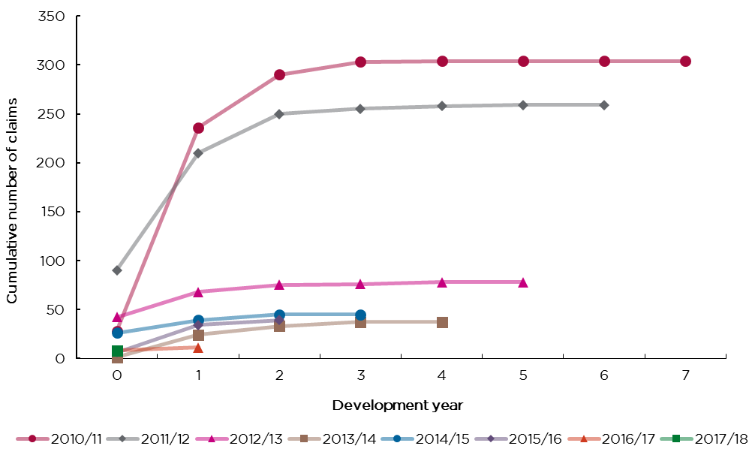
Figure 25: Other claims - cumulative number of claims lodged by year insurance issued
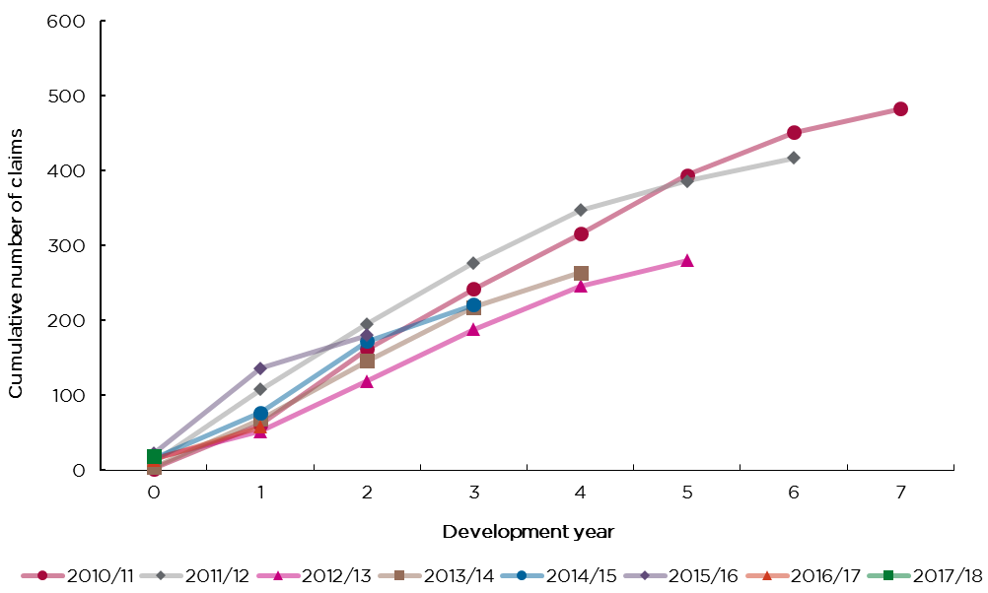

6. Claim payments information
Key comments:
- Over 2017/18, there was $55 million in payments made on approximately 700 claims. Note that single claims may receive multiple payments over several years.
- Of all claim payments made over 2017/18, $32 million related to major defects. Major defect payments have increased in recent years – this is to be expected as differences in periods of cover will mean that the mix of non-completion and defect payments will differ year-on-year.
- New single dwelling, alterations and new multi dwellings accounted for 41%, 32% and 22% respectively of all claim payments made over 2017/18.
- New multiple dwellings, alterations and new single dwellings had the highest average payment over 2017/18.
- Claim payments related to recent years are below the claim payments from the 2010/11 and 2011/12 issued years as can be seen in charts 31 and 32.

Care should be taken in interpreting claims data for recent years, as it can take many years for claims related to building defects to emerge, and for the full claim payments and costs to be known. Note:
- Claims payment development charts allow for a like-for-like comparison of claims payment by year insurance issued.
- It is important to consider payment “emergence / development patterns” when assessing experience.
- Defect payments have a longer “emergence / development pattern” than non-completion payments.
- The greater the volume of certificates of insurance issued (exposure), the higher the expected payments, all else being equal.
- The payments reported in this section relate to policies issued from 1 July 2010.
- Payments in this section include GST.
Figure 26: Claim payments ($ millions) by year
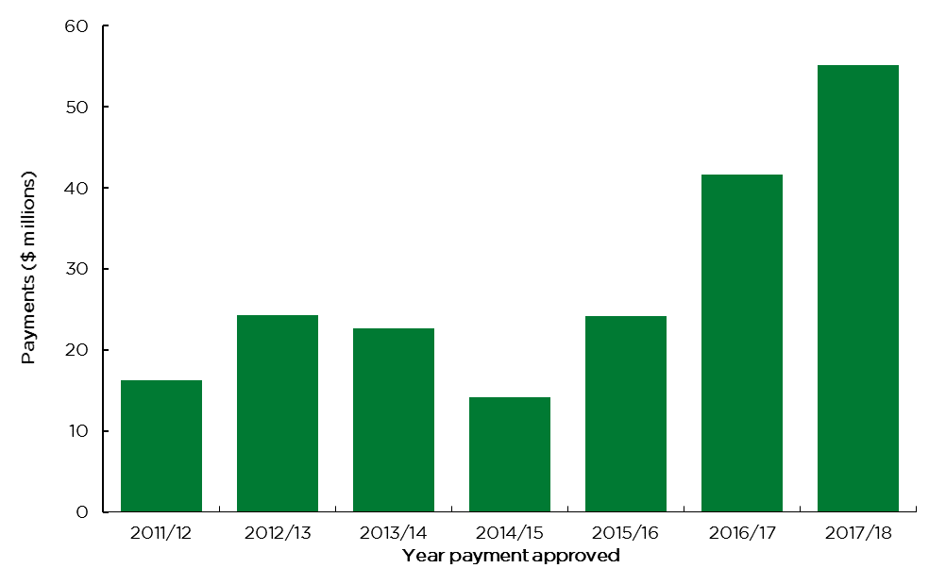
Figure 27: Number of claims with payments and average payment ($ thousands) over time
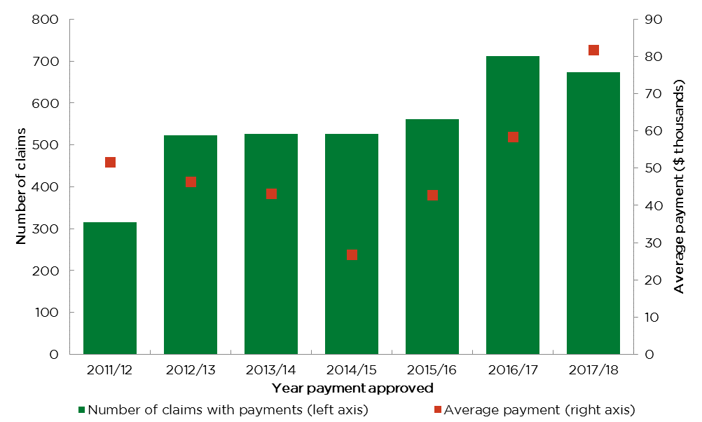
Figure 28: Claim payments ($ millions) by year and type of claim
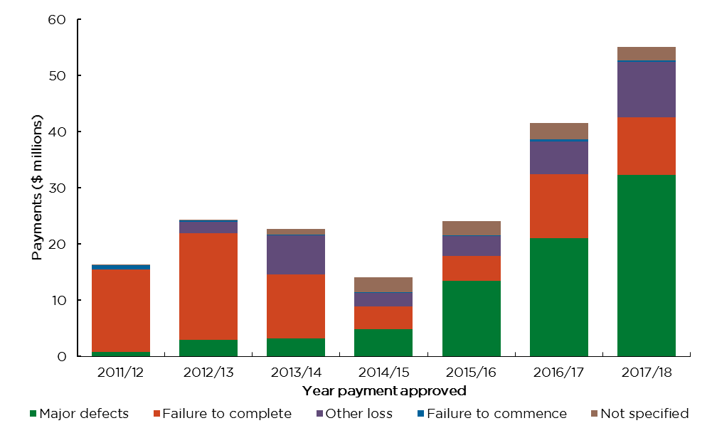
Figure 29: Claim payments ($ millions) by year and construction type
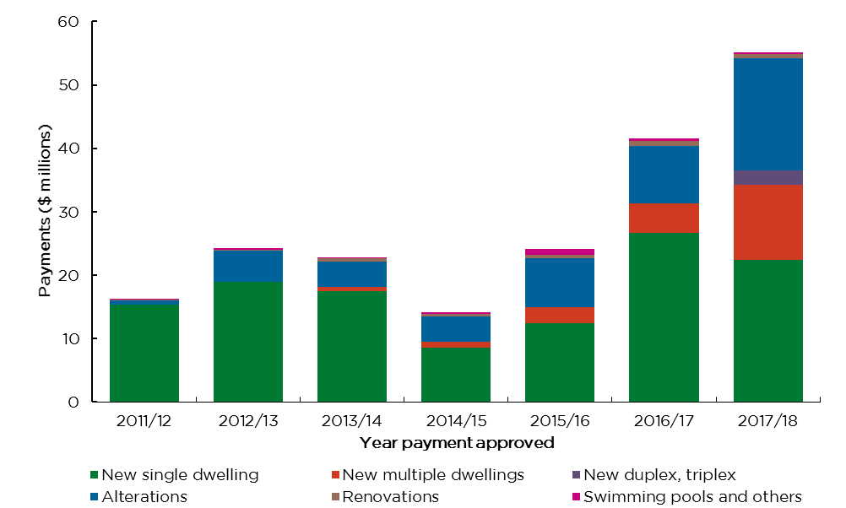
Figure 30: Average claim payments ($ thousands) by year and construction type
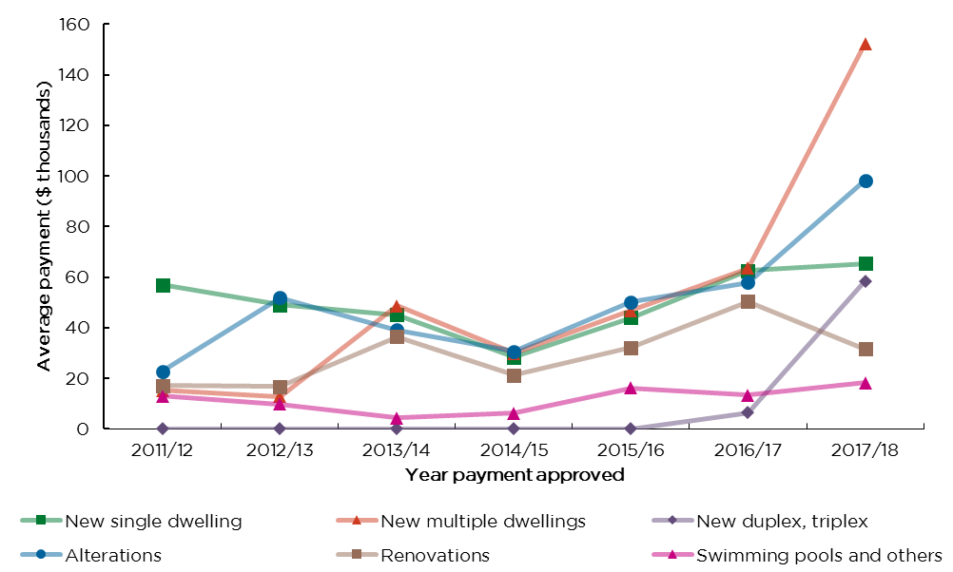
‘New duplex, triplex’ commenced under its own category from 2014/15.
The spike in average payments for new multiple dwellings in 2017/18 was caused by three claims with total payments of $6.8 million in 2017/18.

Claim payment development
Claim payment development charts facilitate:
- A comparison of cumulative claim payments by year insurance issued at the same stage of development. That is, they allow experience to be compared on a like-for-like basis.
- A greater understanding of the typical claim payment patterns.
In these charts, the development year refers to the difference between the financial year of payment and the financial year of certificate of insurance issued. As in Section 5 claim information, non-completion claims refer to failure to commence and failure to complete claims, while other claims refer to major defect claims, other loss claims and claims with multiple claims types or no claim types.
Figure 31: Total claims – Cumulative payments ($ millions) by year insurance issued
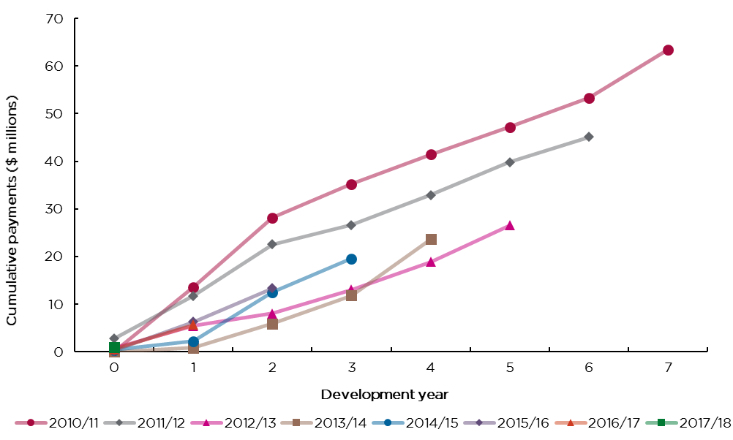
Figure 32: Non-completion claims – Cumulative payments ($ millions) by year insurance issued
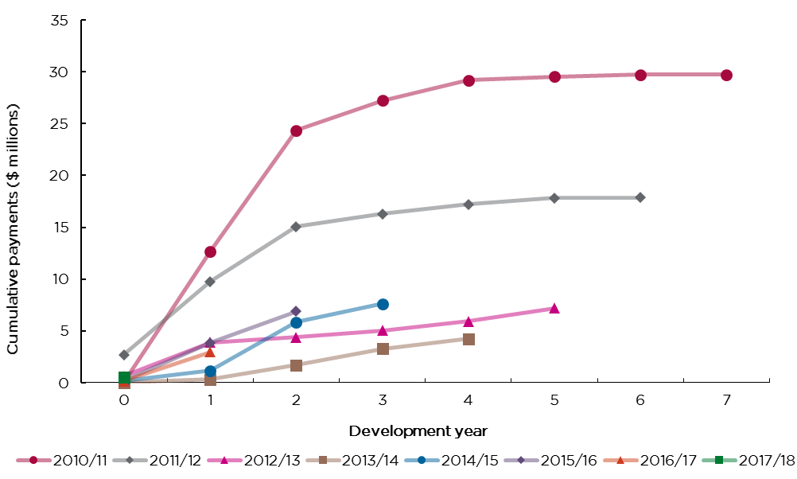
Figure 33: Other claims – Cumulative payments ($ millions) by year insurance issued
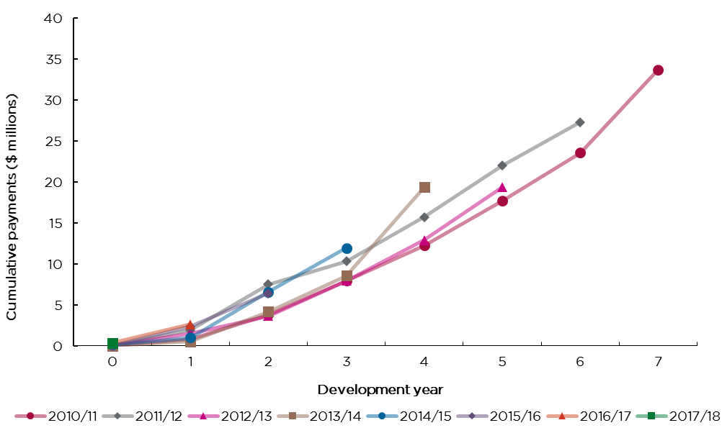
Note: ‘Other claims’ refers to major defect claims, other loss claims and claims with multiple claims types or no claim types.

7. Premiums and claim costs
Key comments:
- The projected ultimate net claims cost (undiscounted) exceeds premium charged across all years.
Figure 34 shows the net claim payments, projected net outstanding cost and premium excluding GST, stamp duty and charges for contracts of insurance entered into from 2010/11 to 2017/18.
Note that no allowance for discounting (such as for normal inflation) has been made to these figures. The net claim payments and projected net outstanding cost figures are sourced from icare HBCF’s Annual Report Financials 2017/18. The premium figures are sourced from data submitted to SIRA.

Figure 34: Net claim payments, projected net outstanding cost and premium excluding GST, stamp duty and charges ($ millions) by certificates of insurance issued year
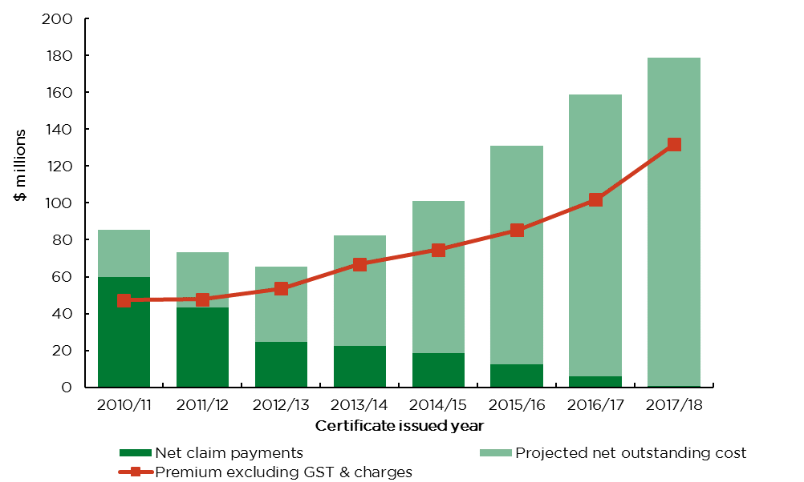
Assuming icare’s projected underwriting loss of $47m more than premium charged, this implies a scheme projected net outstanding cost of $179m (excluding run-off insurers) for FY 2017/18. This equates to an estimated underwriting loss ratio of 136% ($179m projected outstanding claims cost / $132m premium charged). icare published in its Insurance and Care NSW Financial Statements 2017-18 that during 2017/18 it received $138.4m in funding relating to reimbursements of prior year losses and an additional $43m in respect of policies written post 1 July 2018.

Part 2: Claims information for policies issued prior to 1 July 2010
As noted in the preamble, from 1 July 2002 to 30 June 2010 NSW, HBC insurance was written by insurers approved by the Minister. These insurers are referred to as ‘runoff insurers’ in this report. Whilst runoff insurers ceased writing HBC business on or before 30 June 2010, they continue to manage and settle claims on policies written up until that date.

Number of runoff insurer notifications of loss and claims lodged reported
Key comments:
- 25 notifications of loss in 2017/18 down from 104 in 2016/17.
- The number of claims lodged (i.e. notifications of loss which have progressed to become claims lodged), hereinafter referred to as ‘claims’, has decreased by 75%, dropping from 72 in 2016/17 to 18 in 2017/18. 14 (or 78%) of the claims in in 2017/18 related to new single dwellings.
- Insolvency accounted for 94% of runoff claims in 2017/18.
- The volume of runoff insurer claims is expected to continue the downward trend as remaining policies expire.
Home owners can notify their insurer that they have suffered a loss in order to preserve their ability to claim beyond the period of insurance in some circumstances. Not all notifications of loss necessarily progress to become a claim lodged. Notifications of loss can be finalised with no claim lodgement, for example if a home owner succeeds in obtaining remedy from their builder while they are still solvent.
Apart from Figure 35, which relates to notifications of loss (including notifications of loss which have progressed to become a claim lodged), all figures in this section of the scheme report relate only to claims lodged based on year of notification of loss.
Note that the count of the number of claims lodged is determined by their recorded liability status as at the current reporting date of 30 June 2018. At a subsequent reporting date, say as at 30 June 2019, the recorded liability status of some notifications of loss may change as they progressed to become claims lodged, due to changes in the liability decision by the insurer. This would result in a different count of number of claims lodged compared to the historical data for past quarters as reported in the 30 June 2018 report, particularly for more recent quarters.

Figure 35: Number of runoff insurer notifications of loss reported by year
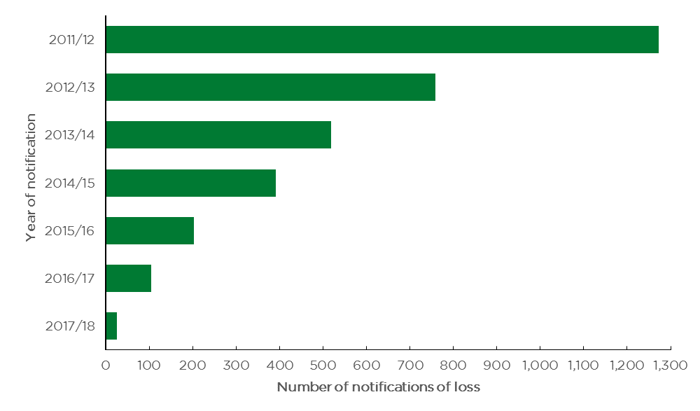
Figure 36: Number of runoff insurer claims lodged by year and claim status
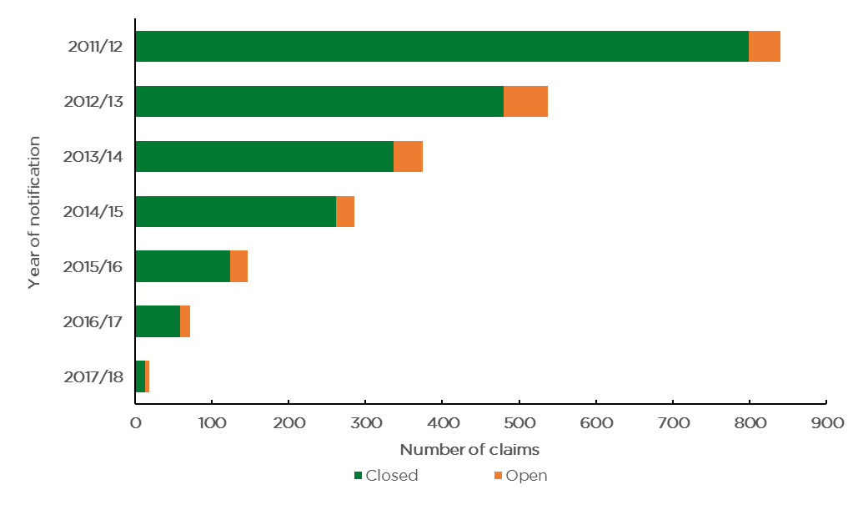
Figure 37: Number of runoff insurer claims lodged by year and liability status
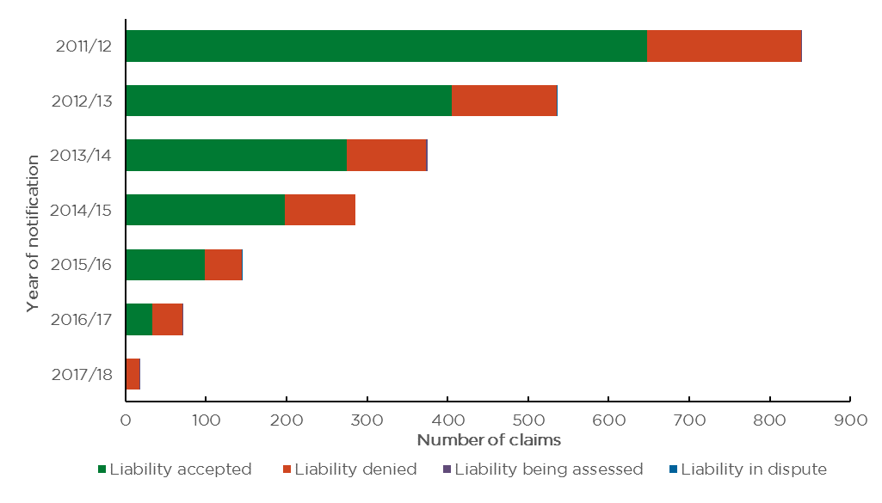
Figure 38: Number of runoff insurer claims lodged where liability has been denied by year and reason declined
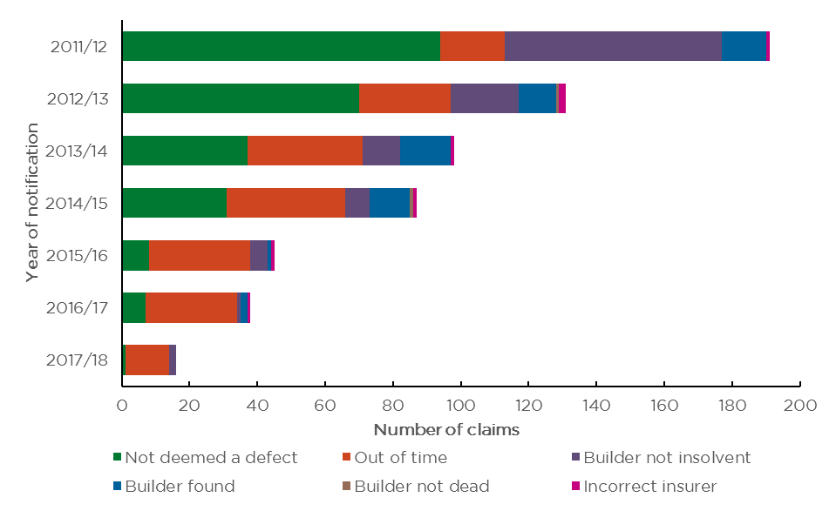
Figure 39: Number of runoff insurer claims lodged by year and principal cause
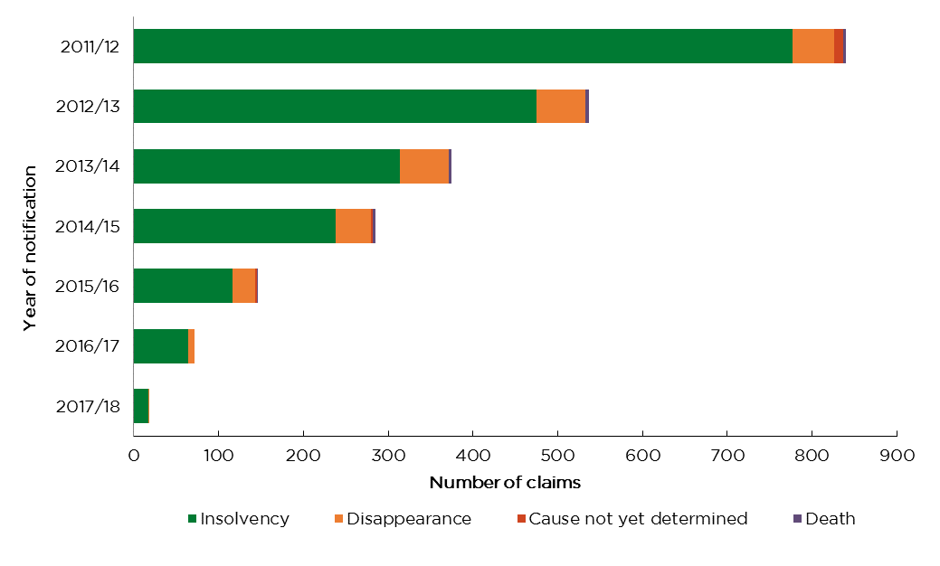
Figure 40: Number of runoff insurer claims lodged by year and type of claim
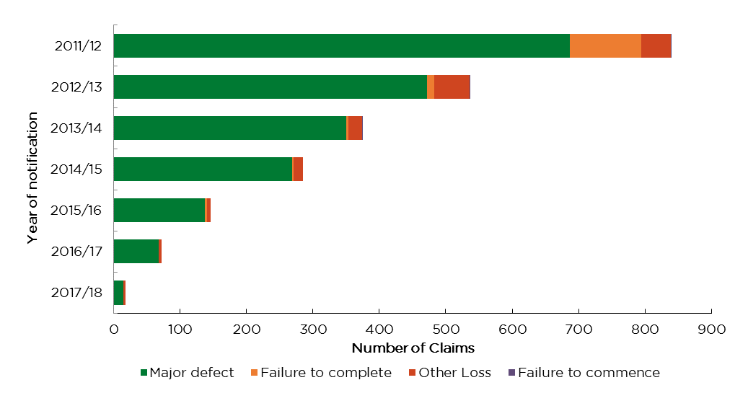
Figure 41: Number of runoff insurer claims lodged by year and construction type
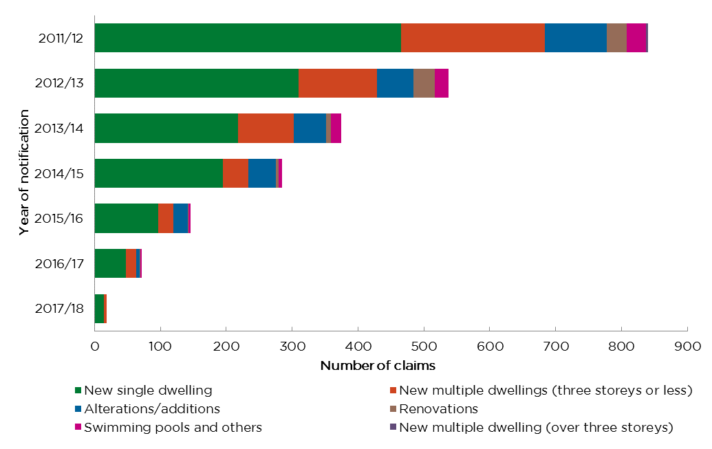
Note: HBC contracts of insurance for ‘new multiple dwellings (greater than three storeys)’ ceased to be issued after December 2003.

Runoff insurer claim payments
Key comments:
- In 2017/18 a total of $35.7 million was paid for runoff insurer claims compared with $46.8 million in the previous year.
- In the June 2018 quarter, a total of $10.3 million was paid compared with $12.5 million in the same quarter last year.
- In the last three years, claim payments due to major defects accounted for over 90% of the total runoff claim payment amounts each year.
- Claim payments for new multi-dwellings (three storeys or less), new single dwelling and alterations accounted for 58%, 16% and 15% respectively of the payments made in 2017/18.
Figure 42: Runoff insurer claim payments ($ millions) by year and type of claim
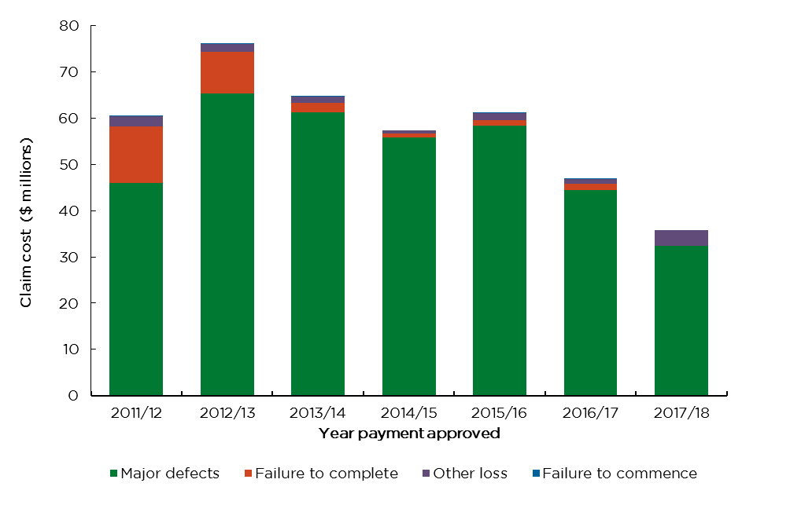
Figure 43: Runoff insurer claim payments ($ millions) by year and construction type
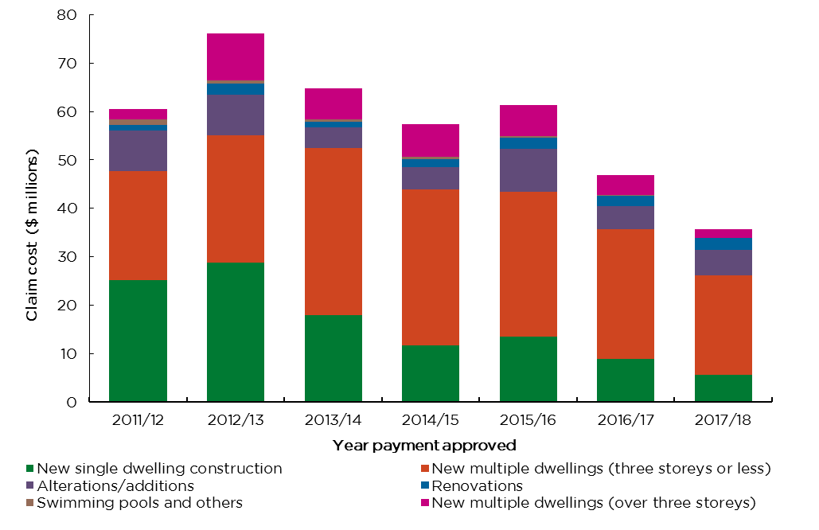
Note: HBC contracts of insurance for high rise buildings, i.e. new multiple dwellings (greater than three storeys), ceased to be issued after December 2003.

Appendices

Appendix 1 - Home building compensation scheme changes in NSW
Change | Description | Effective date
Definition of defects | Structural defects and non-structural defects are called ‘major defects’ and ‘other loss’ respectively.  A new definition is introduced for ‘major defects’. | 15 January 2015
 | ‘External cladding’ is prescribed as a major defect. | 20 April 2018
Eligibility profile | Builder eligibility limit changed from ‘annual turnover limits’ to ‘open job limits’ i.e.– maximum number and value of jobs a builder may have under construction at any given time. | 18 August 2015
Excess fee, if claim accepted | Reduced to $250 (previously $500) | 15 January 2015
Exemption for multi-storey buildings | High rise buildings (more than three storeys that contain multiple dwellings) are no longer covered under the scheme. | 1 January 2004
Exemption for certain stand- alone contracts | Internal paintwork; kitchen and bathroom cabinetry; tennis courts; and ornamental ponds are not covered if work is done as a stand-alone contract. | 15 January 2015
Incomplete work | The cap of 20% of the contract price (including any agreed variations) changed to not less than 20% of the contract price (including any agreed variations) for failing to complete works. | 1 February 2012
HBC Insurer | Runoff insurers ceased writing HBC business. | On or before 30 June 2010
 | icare HBCF became sole provider of HBC insurance. | 1 July 2010
Minimum Cover | Increased to $300,000  (previously $200,000) | 28 February 2007
 | Increased to $340,000  (previously $300,000) | 1 February 2012
 | $340,000 for single (combined) contract | 1 January 2018
 | $340,000 each for separate contracts for construction period or warranty period. | 1 January 2018 (not available in the market yet)
Owner builders cover | No longer issued. Instead, if the property is sold within seven years and six months from the date of issue of the owner builder permit, a consumer warning must be placed in the contract of sale of the owner-builder property stating that the work is not insured. | 15 January 2015
Premium rates | icare HBCF changes in premium rates | 3 April 2017
 |  | 2 October 2017
 |  | 2 October 2018
 | icare HBCF ceased paying commission for brokers distributors. | 3 April 2017
Regulator | State Insurance Regulatory Authority (SIRA) took over the role as HBC scheme regulator from NSW Fair Trading. | 1 September 2015
Reforms | Private insurers or alternate indemnity product providers can apply to SIRA for a licence to enter the market.  Two types of covers may be offered:  - Combined cover, or  - Separate cover for construction period or warranty period. | 1 January 2018
Runoff insurers | Private insurers approved by the Minister to underwrite home building compensation business. | 1 July 2002 – 30 June 2010
Scheme structure | Scheme changed from first resort to last resort. Claim can only be made if the builder died, disappeared or became insolvent. | 1 July 2002
 | Additional trigger – licence suspension due to non- payment of money order introduced (NCAT). | 19 May 2009
Threshold (contract price requiring HBC insurance) | Increased to $20,000  (previously $12,000) | 1 February 2012

Appendix 2 - Glossary
Standard terms | Definitions
Certificate of insurance | A certificate evidencing a contract of insurance has been entered into for residential building work on a dwelling
CIMS | Claims and Insurance Management System used by icare HBCF
Construction type - alterations | Alterations relate to residential building works which are mostly structural.  In this report, both alterations and renovations construction types include works on single or multiple dwellings or duplexes /triplexes.
Construction type - renovations | Renovations relate to residential building works which are mostly non-structural.  In this report, both alterations and renovations construction types include works on single or multiple dwellings or duplexes /triplexes.
Contract of insurance | A contract of insurance under Part 6 of the Home Building Act 1989. Section 104B provides that the requirement to obtain insurance may be met by obtaining coverage through an alternative indemnity product (AIP), however no AIP providers were part of the HBC scheme during the period to which this report relates.
Eligibility | ‘Eligibility’ is the term used to describe the approval by icare HBCF to enable a builder to apply for a HBC certificate of insurance for residential building works in NSW, and the conditions under which the certificate of insurance may be granted
Eligibility utilisation | In this report, eligibility utilisation refers to the percentage of builders’ eligibility open job limit values that has been utilised as at the reporting date. It is calculated as the proportion of:  - total value of contracts of insurance entered into by eligible builders, divided by  - total value of approved eligibility open job limits
GST | Goods and Services Tax
HBC | Home Building Compensation
icare HBCF | The NSW Self Insurance Corporation, trading as icare HBCF, is currently the sole NSW government provider of HBC insurance
Licensed builder | Any holder of a contractor licence under the Home Building Act 1989, including licences in building work categories, trade categories, and categories of specialist work
NCAT | The NSW Civil and Administrative Tribunal (NCAT) is the one-stop-shop for specialist tribunal services in NSW.  Matters previously heard in Consumer, Trader and Tenancy Tribunal (CTTT) are now heard in the Consumer and Commercial Division of the NSW Civil and Consumer Tribunal.
Notification of loss | The notification of an insurer that a loss has become apparent arising from work covered by a contract of insurance for the purposes of s.103BB of the Home Building Act 1989.  Note that not all notifications of loss necessarily progress to become a lodged claim. Notifications of loss can be finalised with no claim lodgement, for example if a home owner succeeds in obtaining a remedy from their builder while they are still solvent.
Open job limit | The approved maximum number and value of jobs an individual licensed builder may have under construction at any point in time as a condition of eligibility granted by icare HBCF
Other loss | In respect of a claim for loss or damage arising other than from a major defect or non-completion of the work
Premium rate | Premium excluding statutory GST, stamp duty and charges as a percentage of building contract value.
Runoff insurers | Insurers that were approved by the Minister to write HBC insurance on or before 30 June 2010. While they all ceased writing business on or before 30 June 2010, runoff insurers continue to manage and settle claims on policies written up until that date.
SIRA | State Insurance Regulatory Authority
Total Premium | Total premium excluding statutory GST, stamp duty and charges. It is the premium amount retained by the insurer to pay claims and the insurer’s expenses.
Year/quarter payment approved | The financial year/quarter the claim payments were approved by icare HBCF.  For runoff insurers, financial year/quarter payment approved refers to the financial year the claim payments were made. The claim payments made during the financial year/quarter is determined by subtracting the cumulative payments as at end of the financial year/quarter from that of the preceding financial year/quarter.

Appendix 3 - Data quality statement
June 2018 home building compensation report
Custodian of the dataset or data source: State Insurance Regulatory Authority (SIRA).
Description
The home building compensation data provides key statistics on home building compensation in NSW.
The current scheme began with policies issued since 1 July 2010. SIRA has been receiving HBC data relating to the current scheme on a monthly basis since the March 2018 quarter. Previously SIRA received this data on a quarterly basis. Eligibility data included in this report up to the March 2018 quarter uses historic snapshots of data previously provided to SIRA.
SIRA continues to receive claims information for policies issued by runoff insurers prior to July 2010 on a quarterly basis. This information covers claims development since 1 July 2002.
Data quality rating
3 stars for:
- institutional environment
- accuracy
- coherence.
Data quality levels by dimension
Institutional environment: Medium – star
Points awarded for:
- Agency publishing this data is the recognised data custodian
- Organisation has an active Data Quality Framework in place
- Data collection is mandated or required by Section 121C of the Home Building Act 1989
- Agency has no commercial interest or conflict of interest in the data.
No points awarded for:
- Data governance roles and responsibilities are not assigned for this dataset or data source.
Find out more about the data quality framework by contacting the custodian.
Accuracy: Medium – star
Points awarded for:
- Data is revised and publicised if errors are identified
- The impact of any adjustments or other changes are reported
- There are no known gaps in the data (for example: non-responses, missing records, data not collected)
- Any factors impacting validity are reported.
No points awarded for:
- This data has not been subject to quality assurance.
Find out more about the quality assurance processes from the custodian.
Coherence: High – star
Points awarded for:
- Standard definitions, common concepts, classifications and data recording practices have been used
- Elements within the data can be meaningfully compared
- This data is generally consistent with similar or related data sources
- This data is part of a time series. There have not been significant changes in the way data items are defined, classified or counted since the start of the series.
No points awarded for:
- There have been changes in data collection since the last release in this series.
Interpretability: Low
No points awarded for:
- No data dictionary is available to explain the meaning of data elements, their origin, format and relationships
- Information is not available about the primary data sources and methods of data collection (for example: instruments, forms and instructions)
- Information is not available to help users evaluate the accuracy of the data and any level of error
- Information is not available to explain concepts, help users correctly interpret the data and understand how it can be used
- Information is not available to explain ambiguous or technical terms used in the data.
Accessibility: Low
Points awarded for:
- This dataset or data source is available in a machine-processable, structured format
- This dataset or data source is not available in a non-proprietary format.
No points awarded for:
- This dataset or data source is not available on the web with an open licence
- This dataset or data source is not described using open standards and persistent identifiers
- This dataset or data source is not linked to other data, to provide context.
Information to help users evaluate relevance
Scope and coverage
SIRA uses the HBC data to regulate the Home Building Compensation insurance in NSW. The HBC data includes eligibility information, securities information, certificates of insurance information, builders’ premium information, claims information and claim payments information.
Target of the data collection: Builders and claimants covered by the NSW home building compensation system.
Geographic detail
Data cover the following geographic area(s): State
At lower levels of geography, the data are represented or apportioned as follows: ABS statistical areas.
Outputs
The data are available as: Published (unstructured content, assembled into a form suitable for wide dissemination).
Other cautions
N/A
Reference period
Period for which the data were obtained: 01/07/2010 – 30/06/2018
There were some changes to the data collection or observation period:
- HBC contracts of insurance for owner-builders are no longer issued after March 2015.
- HBC contracts of insurance for high rise buildings, i.e. new multiple dwellings (greater than three storeys), ceased to be issued after December 2003.
Timing
Updates and revisions: There is no revision policy.
Frequency of production
This information and data in this report is expected to be produced on a regular basis in an appropriate format.
Data disclaimer
The NSW Government is committed to producing data that is accurate, complete and useful. Notwithstanding its commitment to data quality, the NSW Government gives no warranty as to the fitness of this data for a particular purpose. While every effort is made to ensure data quality, the data is provided ‘as is’. The burden for fitness of the data relies completely with the user. The NSW Government shall not be held liable for improper or incorrect use of the data.
Understanding the data quality statement
The data quality statement aims to help you understand how a particular dataset could be used and whether it can be compared with other, similar datasets. It provides a description of the characteristics of the data to help you decide whether the data will be fit for your specific purpose.
About the data quality rating:
The reporting questionnaire asks five questions for each of these data quality dimensions:
- institutional environment
- accuracy
- coherence
- interpretability
- accessibility
For each question: ‘yes’ = 1 point, ‘no’ = 0 points. The number of points determines the quality level for each dimension (high, medium, low).
Only dimensions with four or five points receive a star.
Points | Quality level | Star/No star
0 | Low | No star
1 | Low | No star
2 | Low | No star
3 | Medium | No star
4 | Medium | Star
5 | High | Star
Evaluating data quality
Quality relates to the data’s ‘fitness for purpose’. Users can make different assessments about the quality of the same data, depending on their ‘purpose’ or the way they plan to use the data.
The following questions may help you evaluate data quality for your requirements. This list is not exhaustive. Generate your own questions to assess data quality according to your specific needs and environment.
- What was the primary purpose or aim for collecting the data?
- How well does the coverage (and exclusions) match your needs?
- How useful is this data at small levels of geography?
- Does the population presented by the data match your needs?
- To what extent does the method of data collection seem appropriate for the information being gathered?
- Have standard classifications (e.g. industry or occupation classifications) been used in the collection of the data? If not, why? Does this affect the ability to compare or bring together data from different sources?
- Have rates and percentages been calculated consistently throughout the data?
- Is there a time difference between your reference period, and the reference period of the data?
- What is the gap of time between the reference period (when the data was collected) and the release date of the data?
- Will there be subsequent surveys or data collection exercises for this topic?
- Are there likely to be updates or revisions to the data after official release?

Disclaimer
This publication may contain information that relates to the regulation of workers compensation insurance, motor accident third party (CTP) insurance and home building compensation in NSW. It may include details of some of your obligations under the various schemes that the State Insurance Regulatory Authority (SIRA) administers.
However to ensure you comply with your legal obligations you must refer to the appropriate legislation as currently in force. Up to date legislation can be found at the NSW Legislation website legislation.nsw.gov.au
This publication does not represent a comprehensive statement of the law as it applies to particular problems or to individuals, or as a substitute for legal advice. You should seek independent legal advice if you need assistance on the application of the law to your situation.
This material may be displayed, printed and reproduced without amendment for personal, in-house or
non-commercial use.
Workers and Home Building Compensation Regulation, 92-100 Donnison Street, Gosford, NSW 2250
13 10 50
Website www.sira.nsw.gov.au
Catalogue no. SIRA09021 | © State Insurance Regulatory Authority NSW 0519

This table excludes a relatively small number of certificates without policy number issued from 2011/12 to 2015/16 prior to the commencement of icare HBCF’s Claims and Insurance Management System (CIMS).
Alterations relate to works which are mostly structural, whereas renovations relate to works which are mostly non-structural. Both alterations and renovations construction types include works on single or multiple dwellings or duplexes /triplexes
‘New duplex, triplex’ is combined with ‘New multiple dwellings’ until it commenced under its own category from 2014/15
Source of ABS building approvals: ABS8731.0 Building Approvals, Australia; Tables 12, 22 and 43 ‘Dwelling units approved in new residential buildings - New South Wales’.

